**Project Status Report – Progress 3**

**Overview 2**

**Key Milestones 2**

**Summary of Performance (Since Last Report) 3**

Authentication 3

UI Enhancements 3

Component Integration 4

Development Environment 4

**The Screenshot of Activities 4**

Main page: 4

The trending products at the main page: 5

The booking appointment section and the blog tips section at the main page: 5

The signup section and footnotes: 6

Shop products display: 6

Check appointment section before login: 7

User after login (Example, there is no appointment yet): 7

Blog story section: 8

Contact us section: 8

Login section: 9

Sign in Google (Example): 9

Click logout and display information: 10

Click the “Return to Home” and back to the main page: 10

**Planned Work for Next Period 11**

Finalizing Remaining Functionalities 11

Quality Assurance & Optimization 11

**High-Priority Issues 12**

Cart Functionality 12

Appointment Booking System 12

API Performance 12

Cross-Browser Compatibility 12

Project Management 12

**Issue Logs 13**

**Next steps 13**

**Conclusion 14**

## **Overview**

**Project Name:** TailTales

**Start Date:** Start Date: February 12, 2025

**Report Date:** April 9, 2025

**Team members:** Haroon Ahmed Bajwa, Aryan Tuwar, Vivian Zhonghui Liu, Mrinaal Nagpal

TailTales has entered the final development phase and achieved significant milestones. After implementing secure authentication features, the project is now advancing toward completing its critical user-facing functionalities. Recent updates include UI enhancements to the Contact section and continued refinement of the appointment and shopping experiences. With stable core infrastructure elements, the team is positioned to deliver the remaining features on schedule.

## **Key Milestones**

The TailTales project has achieved significant progress, with 8 of 14 planned components now fully implemented, representing approximately 70% of the project scope. Core infrastructure elements, including the Navbar, Footer, HeroSection, and content sections, were completed early in the development cycle, followed by the successful implementation of TrendingProducts and Authentication features. Most recently, the Contact section was finalized. At the same time, continued development focuses on the remaining user interaction components, including appointment booking, shopping cart functionality, and user profile management, all of which are in various stages of completion.

| **Milestone** | **Planned Date** | **Finished Date** | **Status** |
| --- | --- | --- | --- |
| Footer | February 12, 2025 | February 18, 2025 | ✅ Completed |
| HeroSection | February 12, 2025 | February 18, 2025 | ✅ Completed |
| Navbar | February 12, 2025 | February 18, 2025 | ✅ Completed |
| OurStory | February 12, 2025 | March 11, 2025 | ✅ Completed |
| ShopInfo | February 12, 2025 | March 11, 2025 | ✅ Completed |
| TrendingProducts | February 12, 2025 | April 3, 2025 | ✅ Completed |
| Authentication | February 12, 2025 | April 7, 2025 | ✅ Completed |
| Contact | February 12, 2025 | April 8, 2025 | ✅ Completed |
| AppointmentSection | February 12, 2025 | - | ⏳ In Progress |
| BlogSection | February 12, 2025 | - | ⏳ In Progress |
| CartPage | February 12, 2025 | - | ⏳ In Progress |
| ProfilePage | February 12, 2025 | - | ⏳ In Progress |
| SignupSection | February 12, 2025 | - | ⏳ In Progress |
| CheckAppointment | February 12, 2025 | - | ⏳ In Progress |

## **Summary of Performance (Since Last Report)**

The TailTales development team has made substantial progress during this reporting period, successfully implementing secure authentication through Firebase integration while simultaneously enhancing the user interface across multiple components, most notably the Contact section and the TrendingProducts, BlogSection, and AppointmentSection modulus. These improvements have been achieved within a well-maintained development environment that demonstrates proper separation of concerns through organized component structures, stylesheets, and services, ensuring code maintainability and efficient collaboration among team members. Furthermore, the team has established robust communication channels between interdependent components, with particular attention to the authentication flow and its seamless connection to profile management functionality, laying a solid foundation for the remaining development work.

### **Authentication**

Successfully implemented login and logout functionality with secure session handling via Firebase integration.

### **UI Enhancements**

Completed revisions to the Contact section and significantly updated TrendingProducts.js, BlogSection.js, and AppointmentSection.js for improved user experience and visual consistency.

### **Component Integration**

Ensured proper communication between related components, particularly focusing on the user authentication flow and its connection to profile management.

### **Development Environment**

Maintained consistent code organization with proper separation of components, styles, and services, as evidenced by the project structure.

## **The Screenshot of Activities**

### **Main page:**

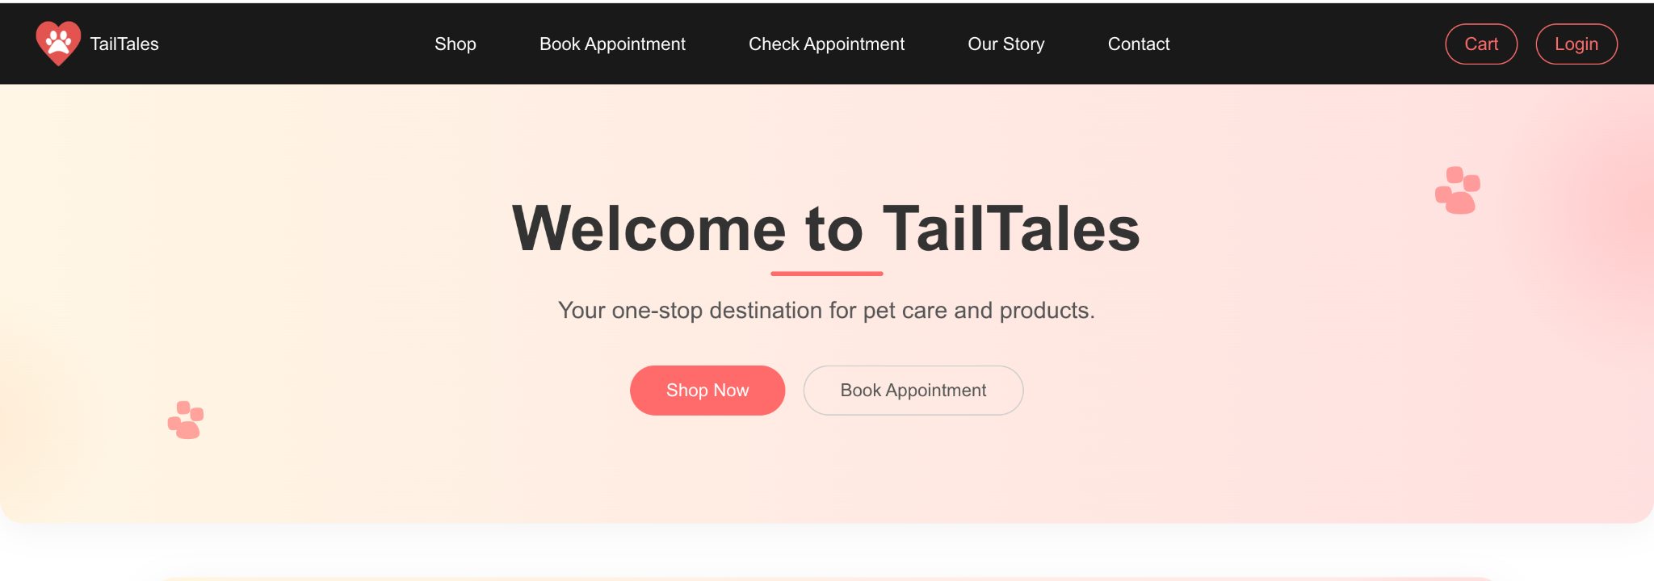

### **The trending products at the main page:**

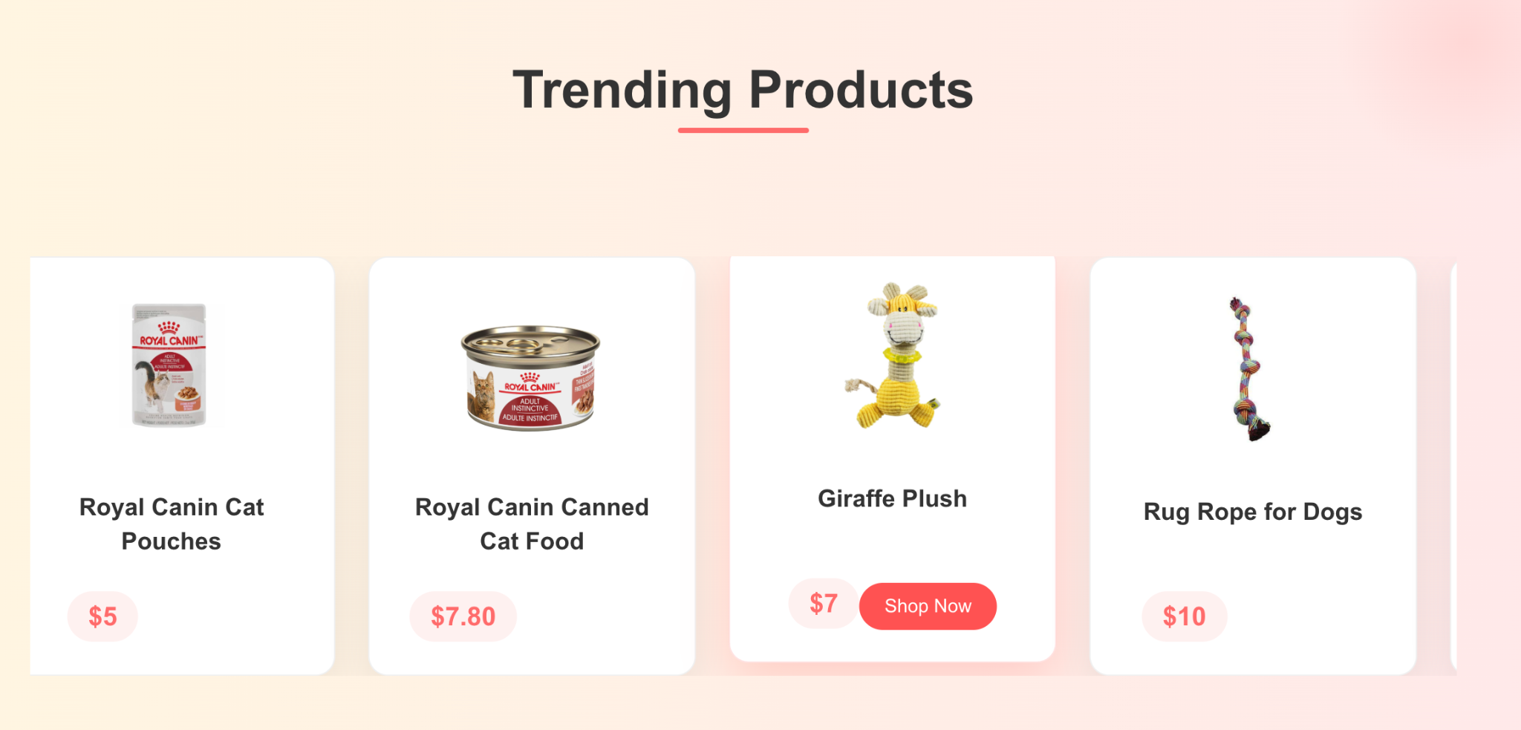

### **The booking appointment section and the blog tips section at the main page:**

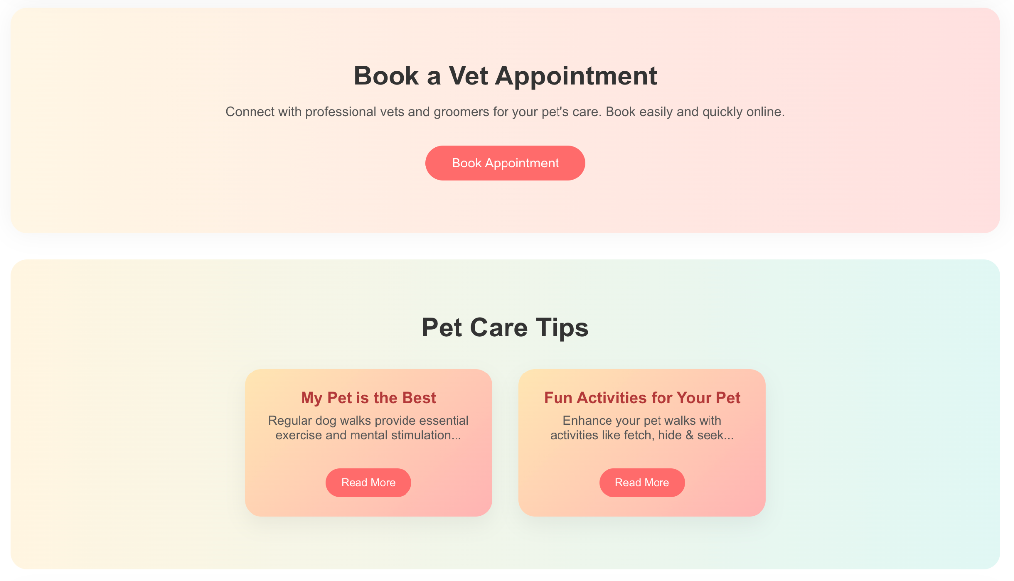

### **The signup section and footnotes:**

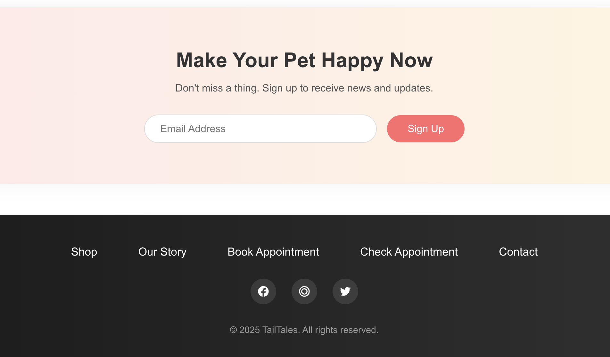

### **Shop products display:**

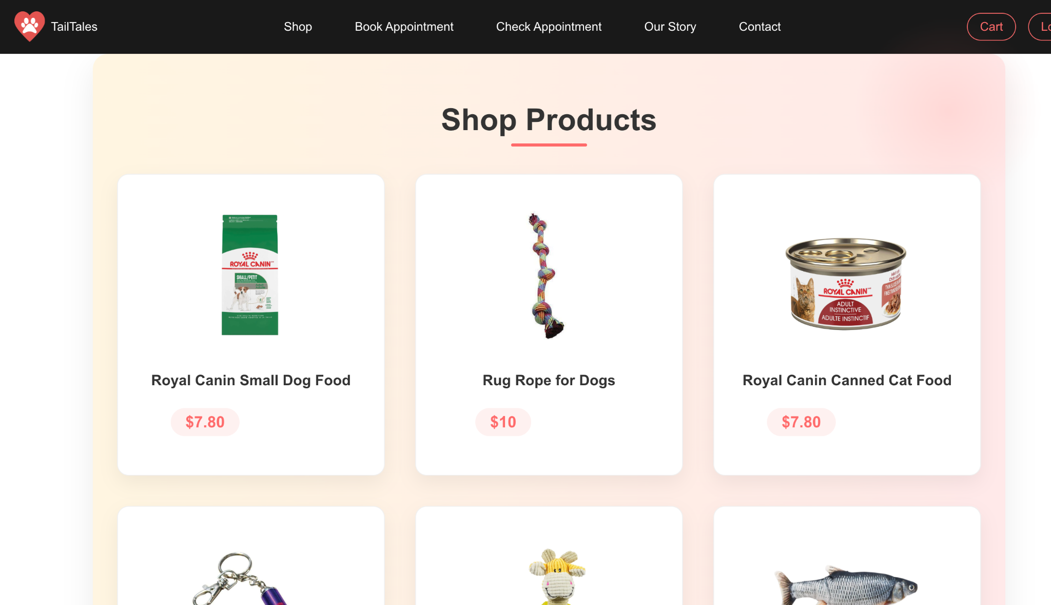

### **Check appointment section before login:**

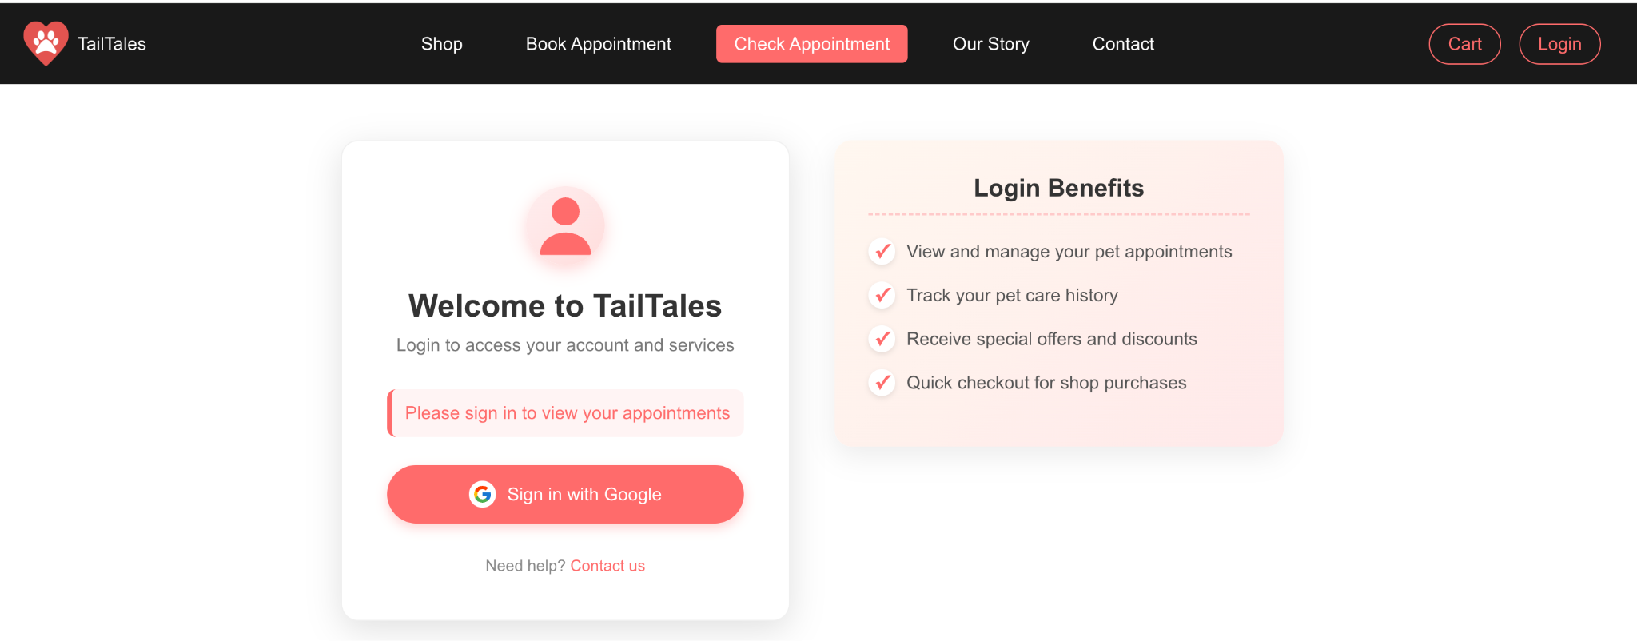

### **User after login (Example, there is no appointment yet):**

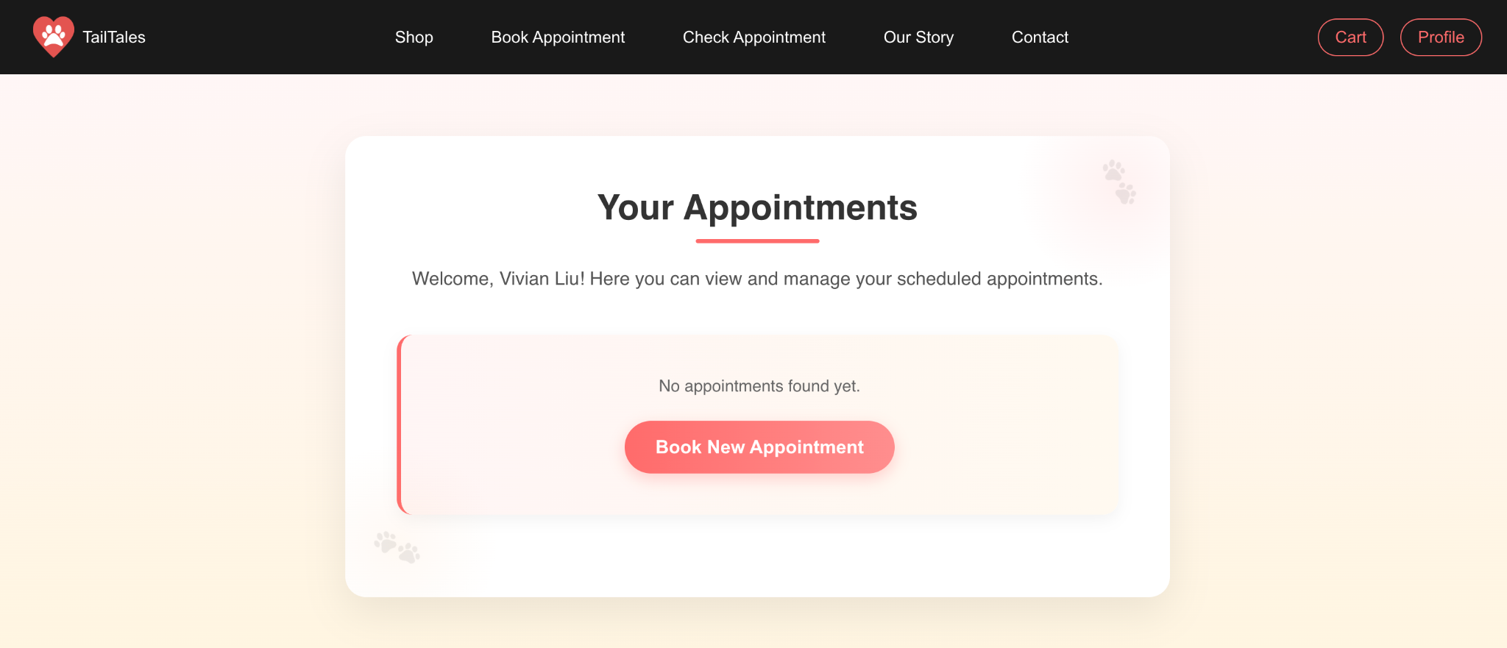

### **Blog story section:**

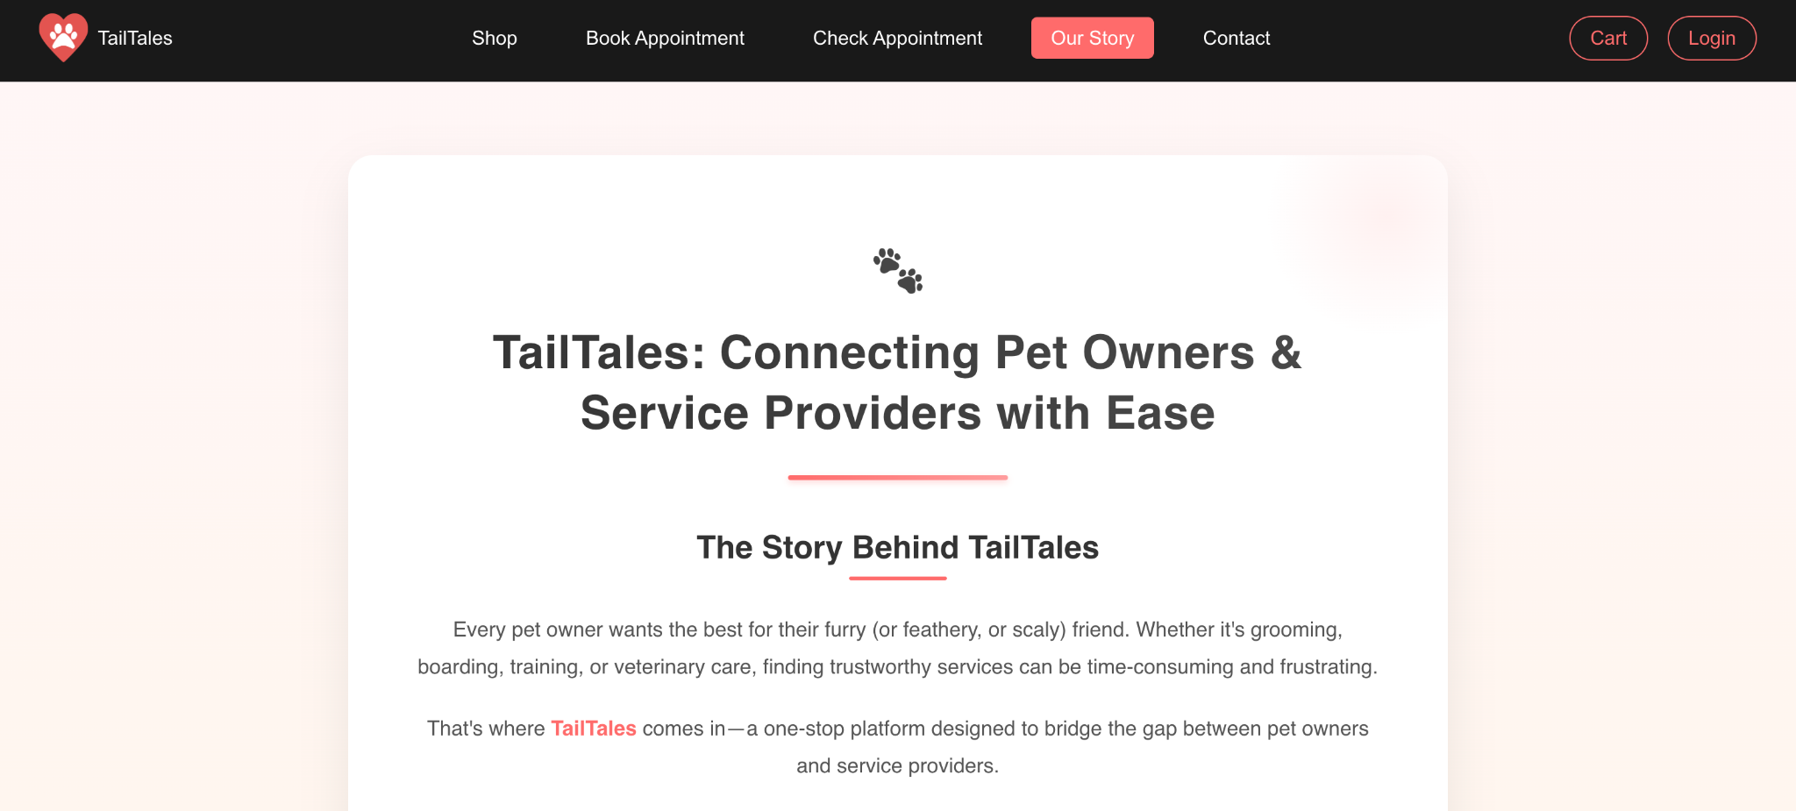

### **Contact us section:**

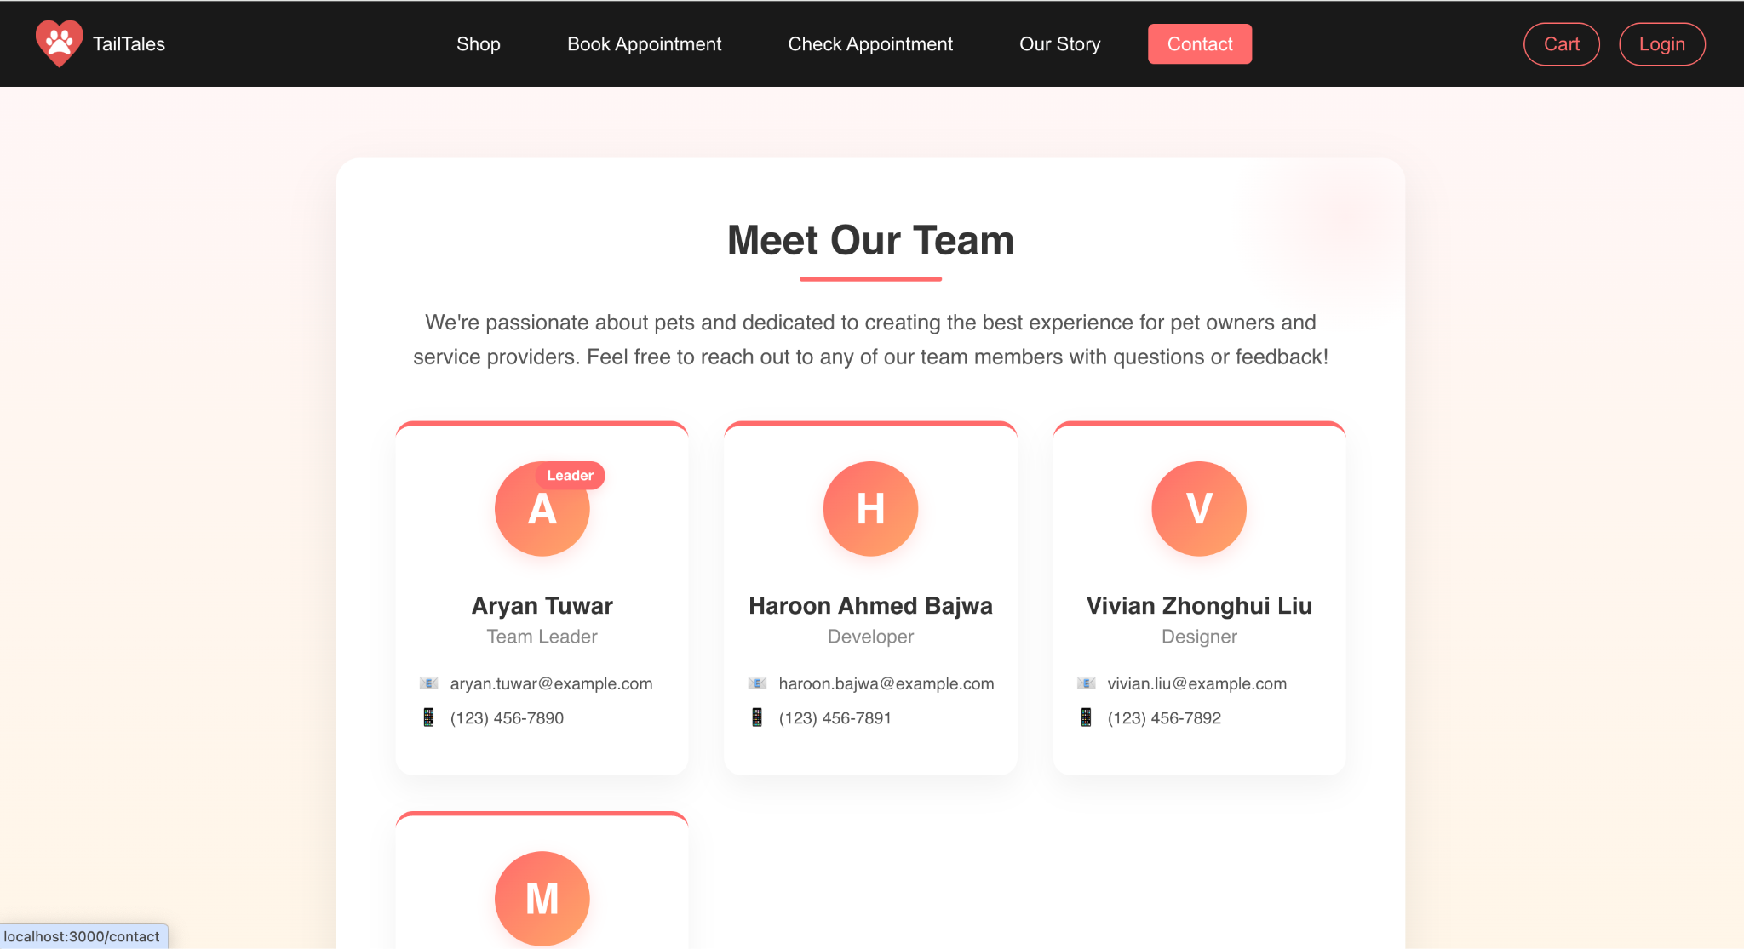

### **Login section:**

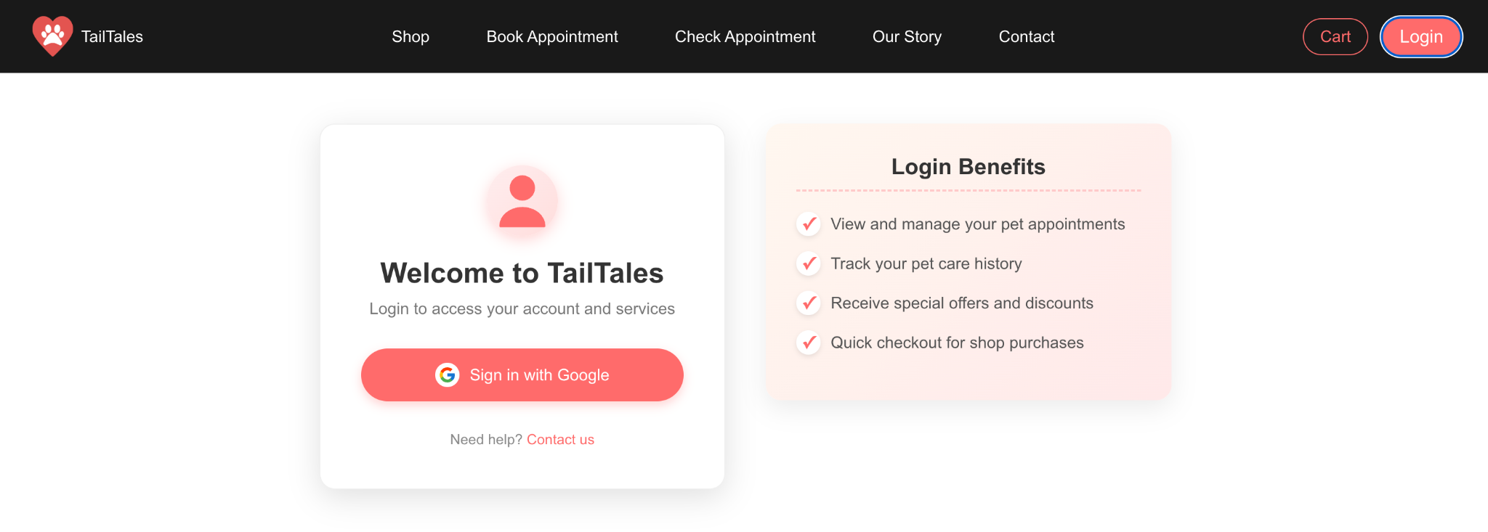

### 

### **Sign in Google (Example):**

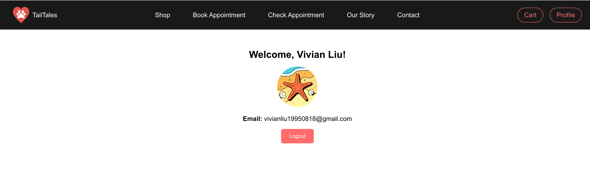

### **Click logout and display information:**

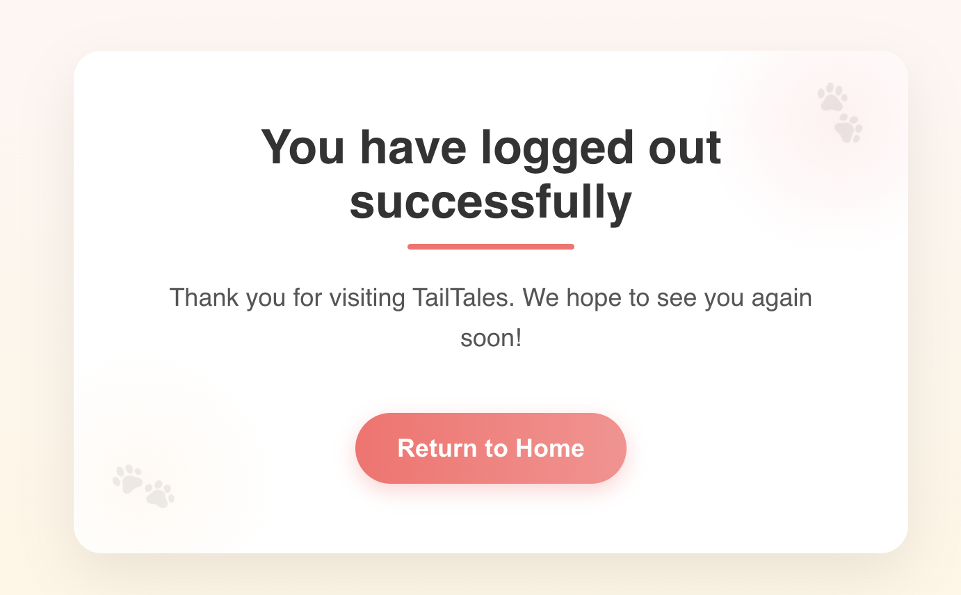

### **Click the “Return to Home” and back to the main page:**

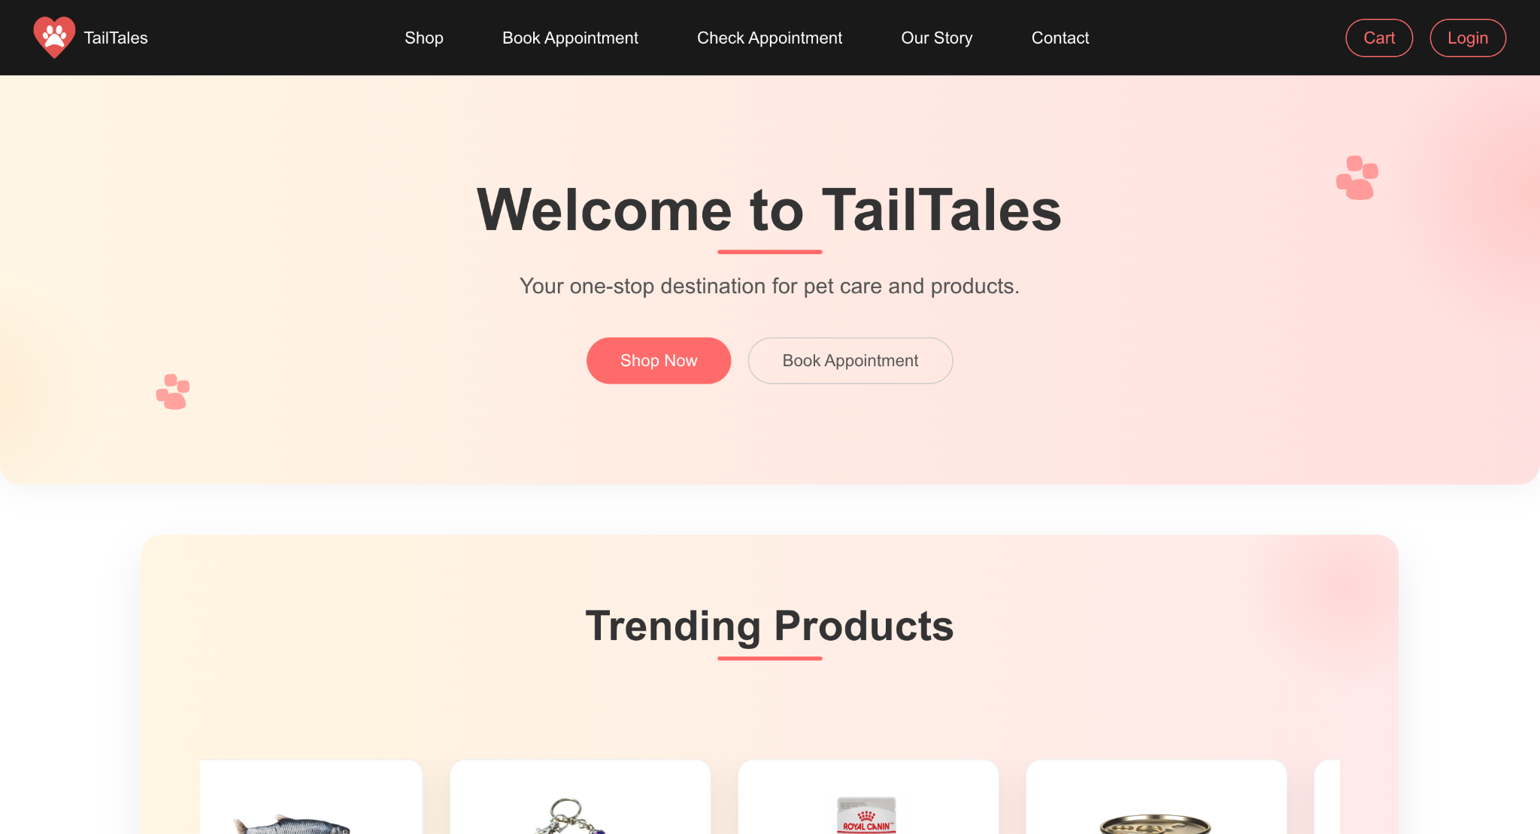

## **Planned Work for Next Period**

Our team will finalize the core functionalities across three key areas while ensuring system quality and reliability in the upcoming period. For appointment management, we will complete the booking interfaces, validation mechanisms, and appointment viewing components. The e-commerce experience will be enhanced by resolving cart functionality issues, implementing secure checkout with payment processing, and adding order tracking capabilities. User account management will be finalized with cross-browser-compatible profile pages and robust signup validation. Simultaneously, we will optimize performance by addressing API latency, implementing caching strategies, and improving resource loading efficiency. Comprehensive testing will verify authentication flows and responsive behaviour, while updated documentation will support developers and end users.

### **Finalizing Remaining Functionalities**

**Appointment Management:**

* Complete time slot selection and booking confirmation interfaces
* Implement appointment validation and conflict prevention
* Finalize the CheckAppointment component for viewing scheduled appointments

**E-commerce Experience:**

* Resolve quantity update issues in the cart functionality
* Complete the secure checkout process with payment integration
* Implement order history and tracking capabilities

**User Account Management:**

* Finish profile page implementation with cross-browser compatibility
* Complete the signup section with proper validation and user role assignment

### **Quality Assurance & Optimization**

**Performance Optimization:**

* Address API response latency issues
* Implement caching strategies for frequently accessed data
* Optimize resource loading for improved page speed

**Testing:**

* Conduct comprehensive testing of the authentication flow
* Verify responsive behaviour across device types
* Perform cross-browser compatibility testing

**Documentation:**

* Update component documentation with the latest functionality descriptions
* Prepare user guides for the appointment and shopping features

## **High-Priority Issues**

Our project faces five high-priority concerns requiring prompt attention before release. Cart quantity updated defects compromise the e-commerce experience, while the appointment system lacks essential time slots and conflict management features critical to our core operations. Backend performance issues are causing unacceptable latency in data-heavy processes, and the profile interface exhibits browser-specific loading failures. Additionally, inconsistent project tracking practices hinder effective team coordination and progress visibility.

### **Cart Functionality**

Quantity update issues require immediate attention to ensure a proper e-commerce experience.

### **Appointment Booking System**

Time slot selection and conflict management need completion to enable core business functionality.

### **API Performance**

Backend optimization is required to address response latency, particularly for data-intensive operations.

### **Cross-Browser Compatibility**

Profile page loading issues on specific browsers must be resolved before release.

### **Project Management**

More consistent task tracking and status updates in Jira are needed for improved team coordination.

## **Issue Logs**

The development team is currently addressing six tracked issues affecting system functionality. Aryan Tuwar has successfully resolved the navbar responsiveness issue and is working on cart quantity update problems while investigating intermittent Firebase authentication token refresh failures. Vivian Liu has been assigned to optimize backend endpoints experiencing response latency. Mrinaal Nagpal is testing fixes for browser compatibility issues in the profile page and beginning work on the appointment validation system to manage booking conflicts properly.

| **Issue** | **Description** | **Status** | **Assigned To** |
| --- | --- | --- | --- |
| Navbar responsiveness | Breaks on smaller screens | Resolved | Aryan Tuwar |
| Cart functionality | Quantity update issues | In Progress | Aryan Tuwar |
| Slow API response | Lag in backend endpoints | Pending | Vivian Liu |
| Profile page loading | Compatibility issues on some browsers | Testing | Mrinaal Nagpal |
| Appointment validation | Booking conflicts not properly handled | New | Mrinaal Nagpal |
| Firebase auth flow | Occasional token refresh issues | New | Aryan Tuwar |

## **Next steps**

* Complete the cart functionality and resolve quantity update issues
* Finalize the appointment booking and management system
* Address API performance concerns and browser compatibility issues
* Implement comprehensive testing across all completed components
* Prepare for user acceptance testing with stakeholder representatives

## **Conclusion**

​​TailTales is progressing according to schedule, with approximately 70% of planned features now complete. The successful authentication implementation represents a significant milestone, establishing the foundation for the remaining user-centric features. With a focused effort on the cart and appointment functionalities, the project is on track for completion within the established timeline. The team will emphasize cross-component integration, performance optimization, and thorough testing to ensure quality product delivery.